Facebook Instant Game Chat Bot Info

Going to follow the Setup Steps as outlined in this document

<https://developers.facebook.com/docs/messenger-platform/getting-started/app-setup>

Before you begin you need to make sure you do the following:

**Set up Game Page**

To create a new Page, go to <https://www.facebook.com/pages/create>

Page category must be “Video Game” and page name must be the name of the game that you’re linking the page to.

**Create Webhook URL**  
I didn’t do this as I had used Glitch (explained later in Messenger Quick Start Tutorial) but steps are here

<https://developers.facebook.com/docs/messenger-platform/getting-started/webhook-setup/>

Now following the “Setup Steps” from the messenger-platform/getting-started/app-setup document

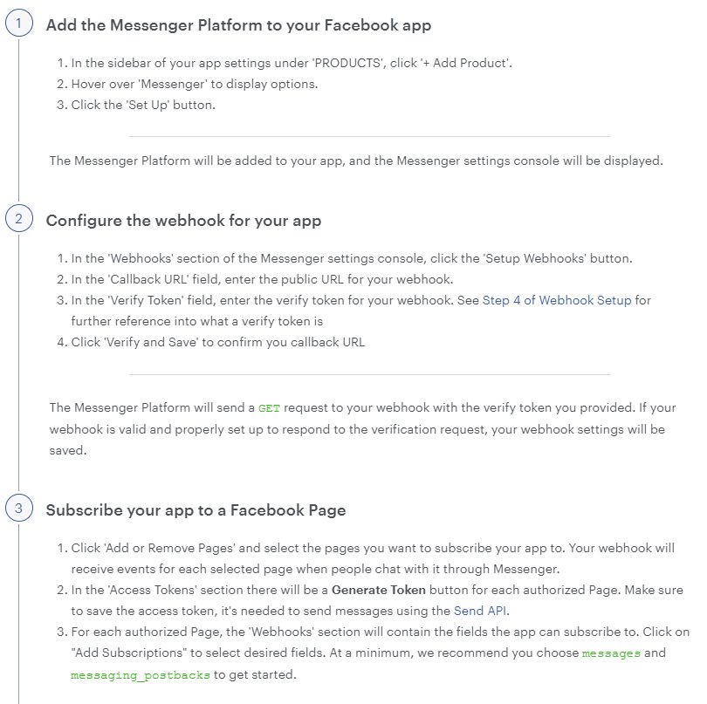

verify token is a random string of your choosing that is hardcoded into your webhook

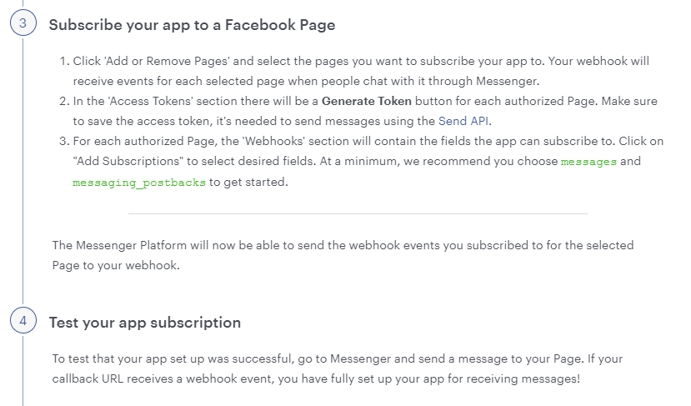

In the facebook developer portal it should now look like this with the page you are subscribed to. I subscribed to all the fields in the “Webhooks” section but the messaging_game_plays is important for testing with Instant Games.

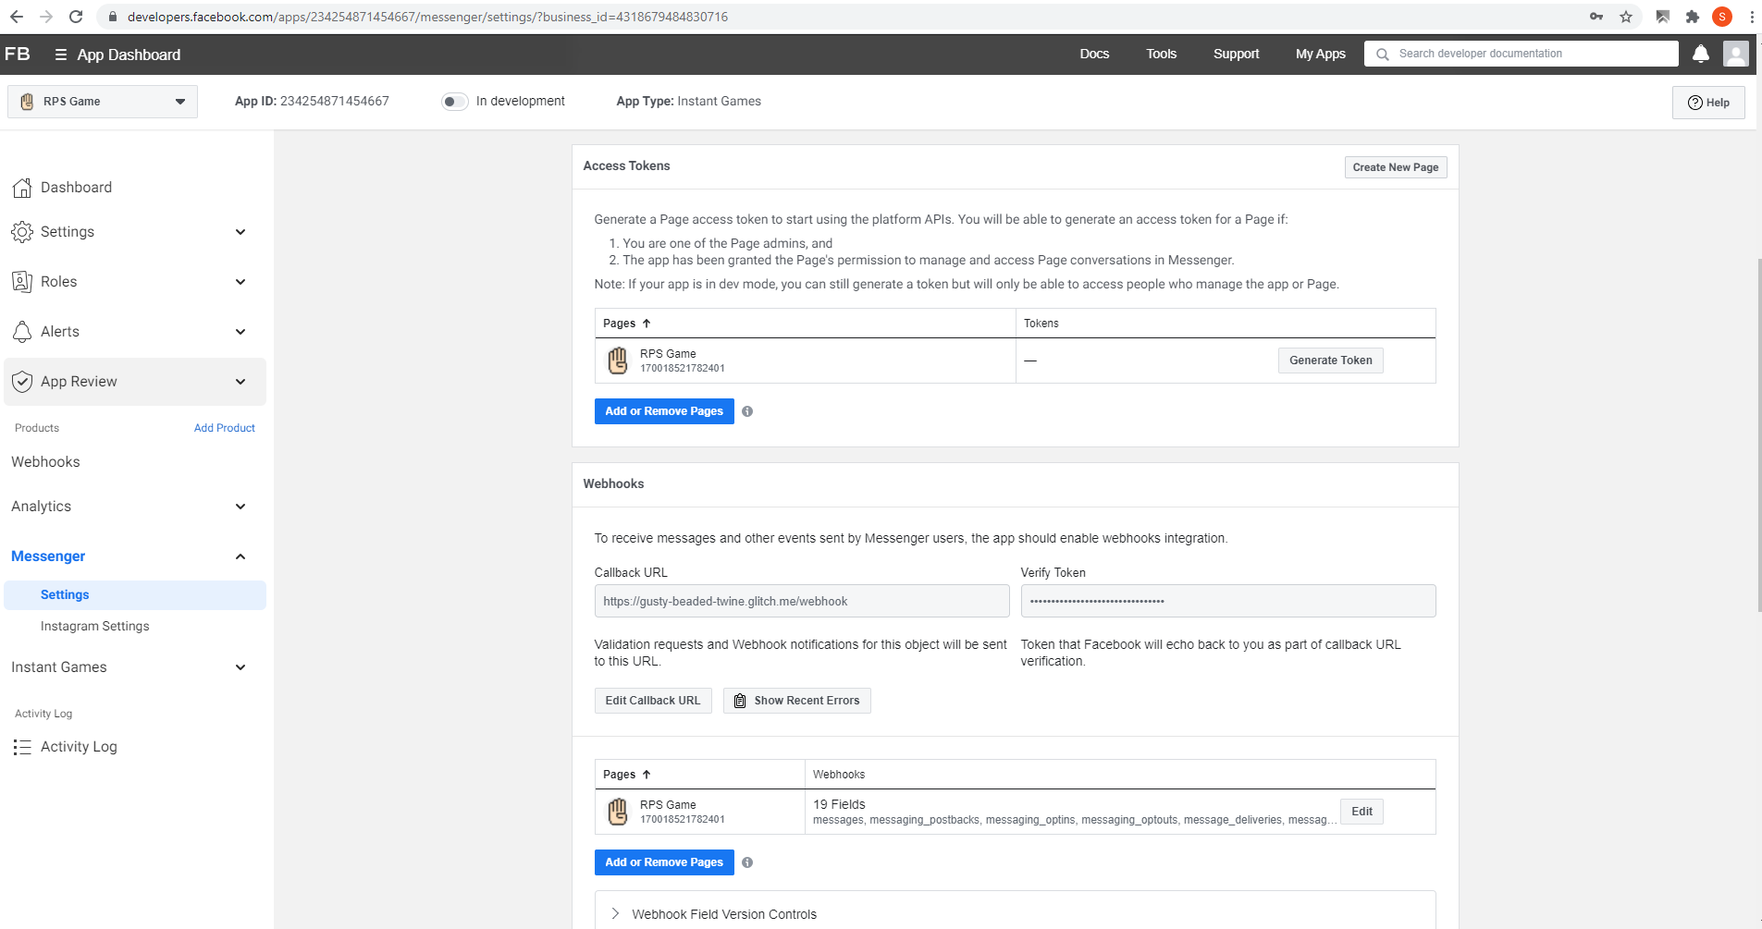

Now finished with the App-Setup tutorial – can move to the Messenger Quick Start Tutorial

<https://developers.facebook.com/docs/messenger-platform/getting-started/quick-start>

I used Option 3 to get a Starter Project (Remix it on Glitch) because I did not have a server to deploy the webhook to.

When you are at the “Get Started” section – you will have already completed steps 1 and 2 from doing the app setup tutorial above. Start at Step 3: Save your page token as an environment variable

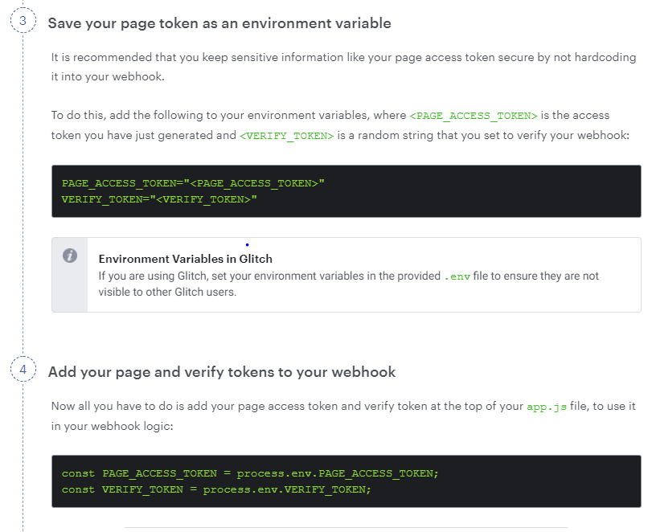

Set-up is complete. Follow the instructions in the Build the Experience section to build the Messenger experience. Note that this code is not specific to instant games. It’s a good start and makes it easy to get familiar with but you won’t necessarily use it for the actual game bot.

ALSO IMPORTANT/TROUBLESHOOTING: It doesn’t really specify this in the configuration steps and gave me a lot of trouble. You also have to link the App Page to the Instant Game through the Developer Dashboard. Go to Instant Games > Details > App Page and link the App Page that you are creating the chat bot for. (Picture below).

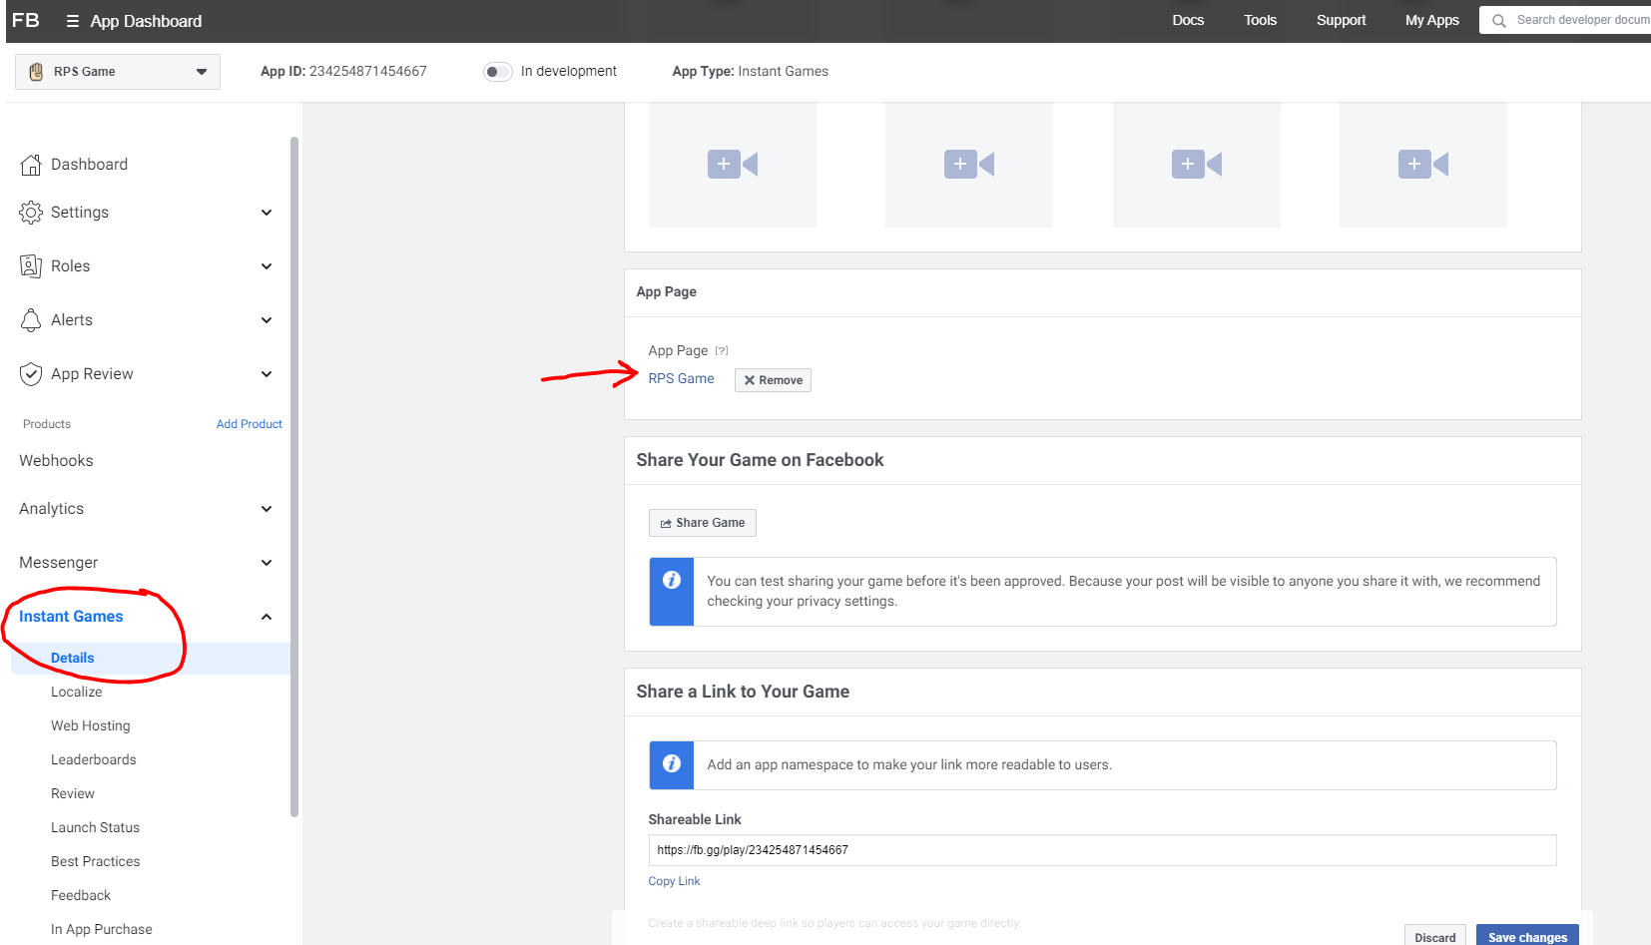

This also isn’t specified but you need to add an App Icon (1024x1024) (found in same Instant Games > Details section) and a Privacy Policy URL (Settings > Basic)

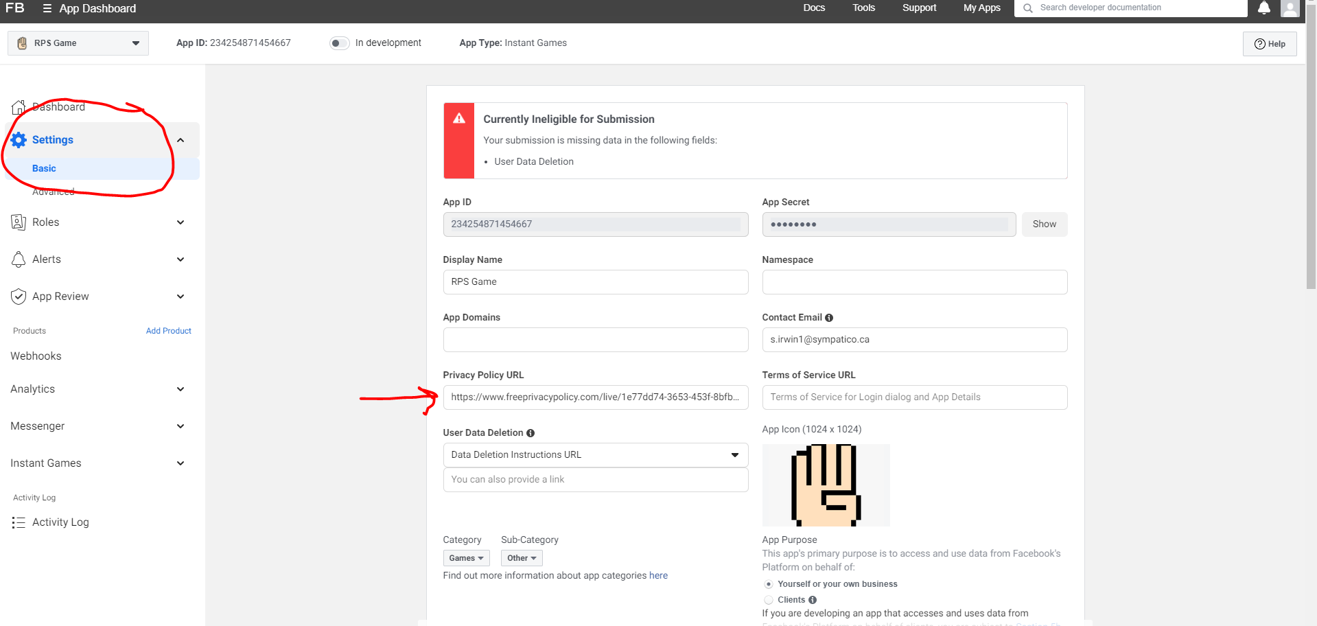

Its really strange and the documents didn’t mention anything about those having to be set up but I found the game/bot didn’t work together unless they were configured.

After these two set-up documents, the facebook documentation doesn’t really hold your hand and outline exact steps anymore for a chat-bot for an Instant Game. I found this site to be helpful for explaining things that weren’t clear through facebook

<https://www.drmop.com/index.php/facebook-instant-games-tutorials/>

Here is the link to the storyboard/planning for Facebook Platform so you can get an idea of the tasks/features needed.

<https://drive.google.com/drive/folders/1m2YBT9y4xrD3fY4M4H9yv5pFACi3_kSd?usp=sharing>

This is what I was able to come up with some simplified examples/proof-of-concepts for (and how to see them in the test game):

**Passing data from the game to the bot**

If you lose or win a regular game (first to 3) the data will be sent from the game and the bot will respond with a You Win or You Lost message

**Passing data to the bot from the game (aka Entry Point Data)**If you lose, the You Lost message will set entry point data so that when you click the “Rematch!” button in the bot message you will be brought back to the game and start with a score of 2

**Choosing a context and switching into it**

Instead of clicking the “start game” button from the main screen click on Play with a Friend. If you inspect the page you can see that before the context was “SOLO” and there was no context id. When the button is clicked a menu will come up and choose a friend to play. Once you choose a friend in the console you can see that the context has switched to “THREAD” and there is now a context id associated with the game.

**Posting context updates (aka Game Updates)**

Once you have chose a friend to play I set it up so that a context update (message) is sent to the player that you selected to play. These updates are different from the “Chat Bot” because they are sent within the chat thread (its not like you’re seeing the message come from the chat bot it shows up “natively” in your conversation – Im not sure how to describe this)

As I mentioned above the tutorials from drmop.com are helpful at explaining these concepts in greater detail.

<https://www.drmop.com/index.php/facebook-instant-games-tutorials/>

Link to my Glitch Project (code for bot.js)

<https://glitch.com/edit/#!/gusty-beaded-twine>

The rest of the information I included as comments in the code.